DAW Programming
Danyel Bruggink
Andy Trent
Will Holcomb

Software Requirements Specification

3D Robotic Arm Simulator

I. Introduction 1
II. Specifications 1
A. Robot Specification 1
B. Interface Design Specification 2
C. Interaction Specification 3
D. Data Structures Relationships Specification 6
III. Bibliography 1

Table 1: Arm Length Coordinate Parameters 1
Figure 1: Functional layout specification 2
Figure 2: Layout prototype 3
Figure 3: User interaction state machine 5
Figure 4: Entity relationship diagram

Introduction

This program was begun fall semester in Computer Science 401 by Andy Trent, Lewis Baumstark, and Michael Sandt. The original implementation was a two dimensional simulation the implemented a language developed by Baumstark. In spring semester 1999 this project is being heavily revised and redone by Will Holcomb, Andy Trent, and Danyel Bruggink. The goal of the project is to implement a simulation of a robotic arm using three dimensional graphics and to allow it to interact with objects in a three dimensional virtual world.

The program as developed through the process of this class will be to have a program which allows a user to have a single robot to interact with a single item. It will have the capacity to process a program into a set of actions on the factory floor.

In its current form the program is designed to allow students to get experience with the concepts of factory design. The eventual goal for this program is to allow a user to implement a virtual factory wherein different robots may be placed and may interact with a variety of objects. Using this program a user would be able to model an entire factory floor and develop more efficient layouts. The robot control system will implement higher level aspects of efficiency and fault tolerance.

The purpose of this paper if to detail the specifics of the interface layout for the project and the data structures design.

Details about the ongoing development of this project is available on our project webpage at http://www.csc.tntech.edu/~dmbruggi.

Specifications

Robot Specification

The specific robot that is being modeled in our simulation will be a Unimation Puma 560 style robot and it will respond to commands given to it according to the specifications of the VAL-II robotics programming language.

The specifications for the robot’s joint-link parameters according to the Denavit-Hartenberg representation:

PUMA Robot Arm Link Coordinate Parameters
Joint i | θ_{i} | α_{i} | a_{i} (mm) | d_{i} (mm) | Range
1 | 90 | -90 | 0 | 0 | -160 to +160
2 | 0 | 0 | 432 | 149.5 | -225 to +45
3 | 90 | 90 | 0 | 0 | -45 to +225
4 | 0 | -90 | 0 | 423 | -110 to +170
5 | 0 | 90 | 0 | 0 | -100 to +100
6 | 0 | 0 | 0 | 56.5 | -266 to +266
Table 2: Arm Length Coordinate Parameters

Interface Design Specification

The functional aspects of the layout will look like this:

Figure 5: Functional layout specification

Program Input

Factory Inventory

Item Pallet

Program Status

Factory Floor

There are five main parts of the interface; as follows:
- Program Input – This is where the user will be allowed to enter and submit programs written in the VAL-II programming language.
- Program Status – Status reports concerning the operation of the program and the operation of the robot will appear here. Error such as invalid programming will be noted here.
- Factory Floor – This will contain a three dimensional representation of the robot and any robots in the robots environment. This part of the interface will provide the user with an animation of the robot performing its programs as specified in the Program Input.
- Item Pallet – From this part of the user will be able to select an item to drag onto the factory floor for the robot to interact with.
- Factory Inventory – This part of the layout will query a database and from that database will construct a listing of the items on the factory floor as well as properties of those objects. It will also allow the user to change properties of the objects on the floor.

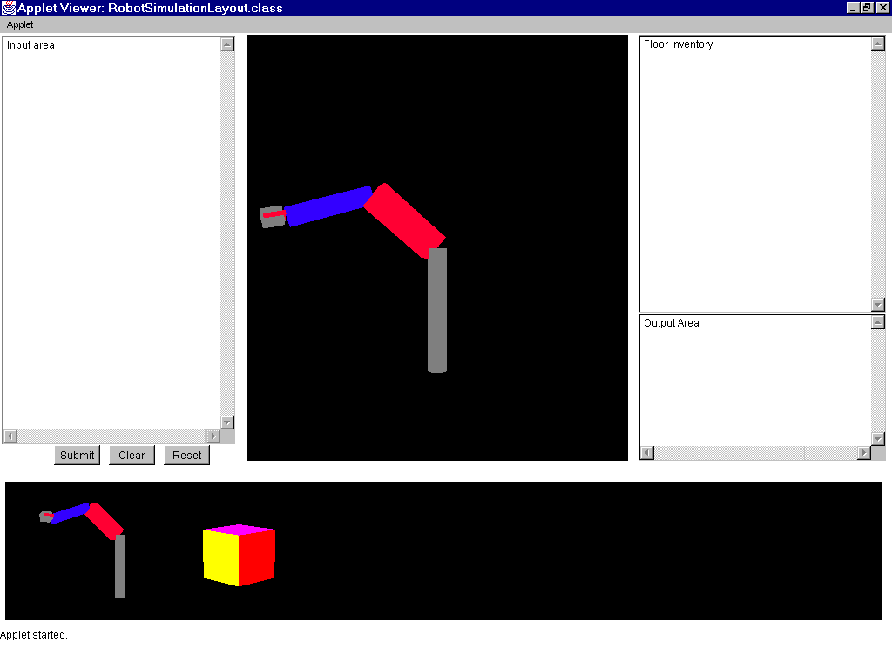A prototype of the layout looks like this:

Figure 6: Layout prototype

Interaction Specification

The program will begin with no items on the factory floor. The user will be able to drag a robot from the item pallet to the factory floor and place it as necessary. Also the user will be able to drag an item from the item pallet onto the floor and place it as necessary. The user will then be able to enter a program in the input box and submit it to the robot. The robot will then perform as it was commanded. Also, each item on the floor will have an entry in the factory inventory and the user will be able to alter characteristics of the item there.
The user interaction can be modeled using a state machine as shown in figure 3:
On
Off
Kill
Applet destroyed

Interpreter
Idle
Program Entered
Process
Program
Information entered in the program input box
Applet started
Submit button pressed
Clear button pressed
Program processed
Add
Factory Floor without Robot
Factory Floor with Robot
Applet started
Add part
Reset pressed
Add robot
Add part
Reset pressed
Figure 7: User interaction state machine

There are two primary states that the program can exist in:
- Off which is simply that the program has been closed down and the user is not able to interact with it anymore.
- On which is where the user is able to interact with the robot and issue commands. The On state is subdivided into three processes each of which is running simultaneously and the user may interact with any one of them at a given time. The states are:

  - Kill which is simply that the user destroys the program. Since this program may be run as a java applet imbedded in a webpage, then this would happen when the user leaves the webpage that the applet is on, also this action could be performed by the user destroying the applet from a variety of other ways depending on how they are running it.
  - Interpreter which is where the user will be interacting with a text box entering commands in the VAL-II programming language. The Interpreter consists of three states which allow the user to command the robot. The states are:
    - Idle which is what the program entry box is created at. No program is entered yet and the box is simply blank. When the user enters text into the box this transitions them to the Program Entered state:
    - Program Entered which represents that they have attempted to enter a program to command the robot. At this point they may hit the clear button which will take them back to Idle or they may hit the submit button which will move them to the submit button which will move them to Process Program.
    - Process Program this is the state where the text that the user entered is analyzed and commands based on it are sent to the robot. Also this is where, if there are any errors, messages will be sent to the program output telling the user what is wrong.
  - Add describes the process by which items are added to the factory floor by the user. There are two main states.
    - Factory Floor without Robot is the state that first exists when the program is initialized. At this point the user may drag as many parts from the item pallet to the floor as he wishes to. Also if the reset button is pressed the factory floor is cleared. If the user drags a robot from the item pallet to the factory floor to the item pallet then the state changes to Factory Floor with Robot.
    - Factory Floor with Robot is the state where a robot is on the factory floor. The user may add more parts to the factory floor or may press the reset button. If the reset button is pressed then the state switches back to Factory Floor without Robot.

Data Structures Relationships Specification

The primary data structures will be:
- Parser which will process the program entered by the user to command the robot.
- Robot which will interact with items placed on the factory floor.
- Database which will maintain information about the objects on the factory floor.
- Pallet which a user will be able to select items and a robot from and drag them onto the factory floor.
- Item which will be a three dimensional representation of a shape or combination of shapes.

Their relationships are detailed in the entity relationship diagram in figure four.
Parser
commands
Robot
initializes
Pallet
initializes
Item
updates
Database
updates
Name
Location
Location
Name
Orientation
Language
Possession
1
1
1
1
1
1
N
N
1
1
Figure 8: Entity relationship diagram

Bibliography

- Bruce E. Shimano, Clifford C. Geschke and Charles H. Spalding III, “VAL-II – A Robot Programming Language and Control System”, Robotics Research by Brady and Paul, MIT press, 1984.

